**EXPERIMENT NO. 1:** Design an LED flasher.

**CIRCUIT DIAGRAM**

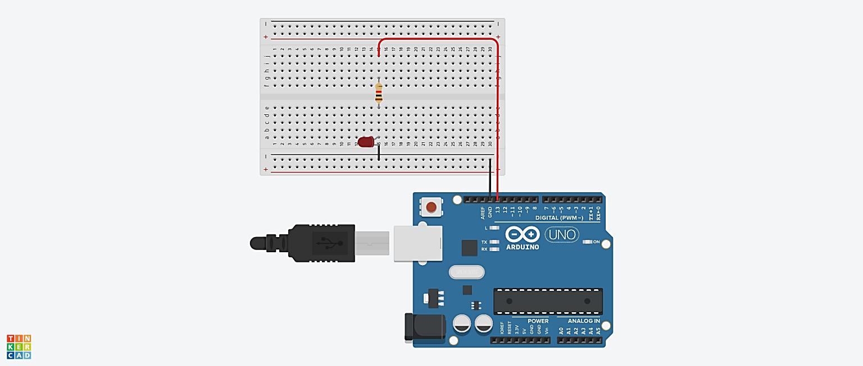

**THEORY**

**CONCEPT USED**

**Breadboard**

A breadboard is used to build and test circuits quickly before finalizing any circuit design. The breadboard has many holes into which circuit components like ICs and resistors can be inserted.

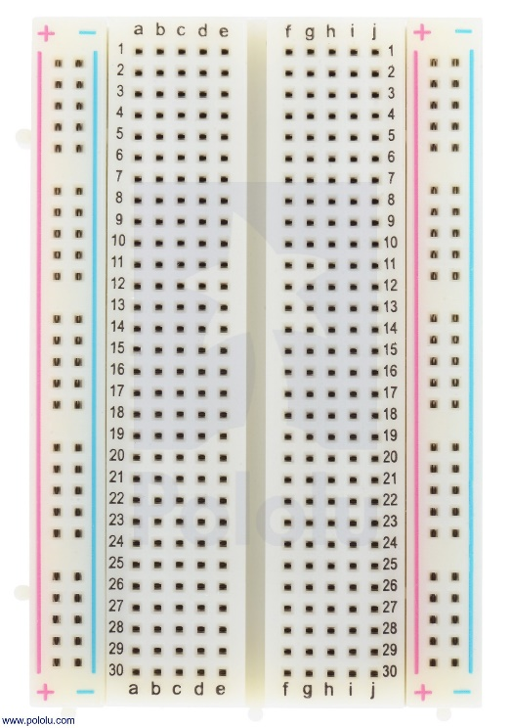

The bread board has strips of metal which run underneath the board and connect the holes on the top of the board. Note that the top and bottom rows of holes are connected horizontally while the remaining holes are connected vertically.

**LED**

A light-emitting diode (LED) is a semiconductor device that emits light when an electric current is passed through it. Light is produced when the particles that carry the current (known as electrons and holes) combine together within the semiconductor material.

**Characteristics Of LED:**

* **Polarity:** Polarity is an indication of symmetricity of an electronic component. A Light Emitting Diode, similar to a PN Junction Diode, is not symmetric i.e. it allows current to flow only in one direction.
* **More Current More Light:** LEDs are very sensitive devices and the amount of current flowing through an LED is very important. Also, the brightness of an LED depends on the amount of current drawn by the LED. Every LED is rated with a maximum forward current that is safe to pass through it without burning off the LED. Yes. Allowing current more than the rated current will actually burn the LED.
* **Low Energy Consumption:**  Most of the power delivered to an incandescent light goes to heating the electrons in the filament almost to the point that they emit visible light; it is the excess power beyond this point that provides illumination in the visible part of the electromagnetic spectrum. In LEDs the electrons require far less power to excite them enough to emit light.
* **Long Life:** No fragile parts, as conventional light bulb, to be broken. Light will decay lumen output, but rarely burn out or dead.

**LEARNING & OBSERVATIONS**

1. LED consist of two legs: the longer leg is anode and the shorter is cathode. If the legs are equal by any chance, the smaller part is the anode and the larger part will be the cathode.
2. LEDs are directional, as light travels in one direction only.
3. Current flows from anode to cathode only.
4. Correct Board and USB port information should be selected before uploading the file.

**PROBLEMS & TROUBLESHOOTING**

**Precautions**

1. The wiring/connections should be made proper.
2. Delay should be short to make a chaser.
3. Appropriate resistor should be used to minimize the flow of current so that it does not damage the LED.
4. One should be aware of the errors while running it to fix the problems.

**Learning Outcomes**

1. Fluent in making Series and Parallel connection in a Breadboard.
2. Various methods to identify the anode and cathode of an LED.
3. Programming commands in Arduino IDE.
4. Write program for chasing action of LED.